

**Terra Industrial New Zealand Ltd**

PO Box 16 168

16 Branston Street, Hornby

Christchurch 8441, New Zealand

03 983 2333 tel

03 983 5715 fax

www.TerraCat.co.nz



**CUSTOMER DATA STANDARDS**

Contacts

Contacts

**Terra Industrial New Zealand Ltd**

PO Box 16 168

16 Branston Street, Hornby

Christchurch 8441, New Zealand

03 983 2333 tel

03 983 5715 fax

www.TerraCat.co.nz

29 JUNE 2020

# Customer Data Standards

TC-CDS-Contacts-1.1

## Contacts

Data owners:  
Martin Dowling, David Hotham, Greg McCarthy, Chris Heaton

SMEs:

Geoff Clapp, Stephen Frayle, Greg McCarthy, Stuart Thornley

Responsible:

e.g. Credit Controllers, CSAMs, ISRs, TAMs, Parts team, Service team etc.

Contents

Customer Data Standards 1

Contacts 1

Document History 4

Document information 4

Document amendment history 4

Business Rules 5

Navigation 6

General 8

Contact information 10

Employment Information 12

Miscellaneous details 14

## Document History

### Document information

|  |  |
| --- | --- |
| Current Version | 1.1 |
| Release Date | 19 June 2020 |
| Document Owner | Jessica Macfarlane |

### Document amendment history

|  |  |  |  |
| --- | --- | --- | --- |
| Version | First Release | Sections(a) Amended | Summary of Amendment |
|  |  |  |  |
|  |  |  |  |
|  |  |  |  |
|  |  |  |  |
|  |  |  |  |

|  |  |  |  |
| --- | --- | --- | --- |
|  |  |  |  |
|  |  |  |  |
|  |  |  |  |
|  |  |  |  |
|  |  |  |  |
|  |  |  |  |

## Business Rules

|  |  |
| --- | --- |
| Rule 1 | The Business ERP (NAXT) must be the "One Source of Truth" for Customer Contacts across the Business |
| Rule 2 | Any Business application containing Customer Contacts must be consistent with NAXT, primarily SalesLink (CRM) |
| Rule 3 | Every Customer Contact must have a First Name, Last Name, Phone Number, and Email Address as a minimum |
| Rule 4 | There must be Customer Contacts nominated on each account to participate in Customer surveys unless they opt out |
| Rule 5 | There should only be 1 Customer Contact per account for each survey type or for a combination of multiple surveys (New Sales, Rental, Parts, Service) |
| Rule 6 | Customer Contacts opting not to be contacted must be flagged in NAXT |
| Rule 7 | All Customer Contact additions and updates must be performed through CRM; additions may also be performed through the Credit application process for new Customer accounts |
| Rule 8 | Only nominated Marketing Gatekeepers and the Credit team must have access to create or edit Customer Contacts in NAXT |
| Rule 9 | All record addition requests must be checked in NAXT for potential duplication before creation - NAXT should flag duplicates |
| Rule 10 | All required inputs must be made mandatory in NAXT and must be complete and valid |
| Rule 11 | All Customer Contacts that are no longer relevant must be removed from the Customer record |
| Rule 12 | NAXT user access levels and system functionality must be in accordance with established Business rules |
| Rule 13 | Data Owners must ensure Business rules and Data standards developed are adhered to and ongoing data errors identified are actioned in line with established Business procedures |
| Rule 14 | Nominated SMEs must ensure Business rules and Data standards developed are feasible across all impacted Business areas and work with Data Owners on change management |

## Navigation

GGNZ > Sales and Marketing > Common > Contacts > All contacts

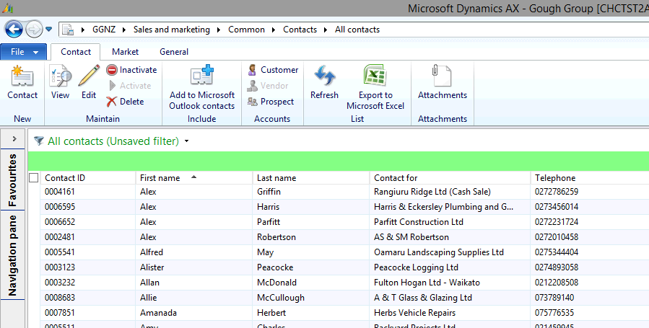

### General

|  |  |  |
| --- | --- | --- |
| **Field** | **Mandatory** | **Data Standard** |
| Contact ID | Y | System generated - Unique identification |
| Contact For | Y | Customer account name |
| Personal Title | N |  |
| First Name | Y | Must be complete and valid. Not all-caps. |
| Middle Name | N | Must be complete and valid. Not all-caps. Not a note field. |
| Last Name | Y | Must be complete and valid. Not all-caps. |
| Gender | N |  |
| Search Name | Y | System auto-fills once name entered |
| Name or Description | Y | Registered Legal Name - must not include "Do Not Use" |
| Address | N | System auto-fills from the Customer record; override if required |

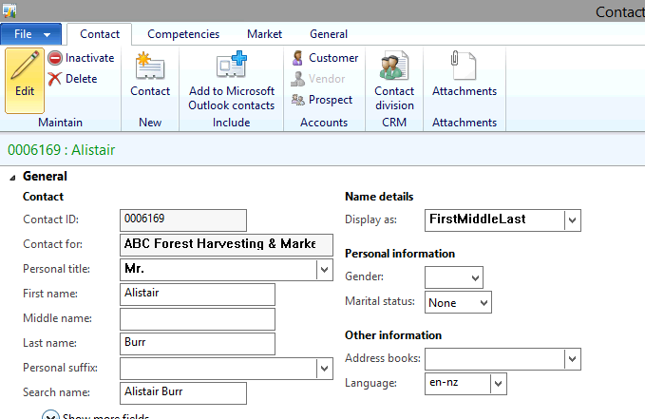

### Contact information

|  |  |  |
| --- | --- | --- |
| **Field** | **Mandatory** | **Data Standard** |
| Type: Phone | N | Numbers only, no spaces, no text, no notes. Purpose default: Business Primary checkbox must be selected once. There is a separate field for extension numbers to use, they should not be added here. |
| Phone > More options > Advanced > Edit contact information > Mobile | N | Tick the box if the phone is a mobile number |
| Type: E-mail Address | N | Purpose default: Business Primary checkbox must be selected once |

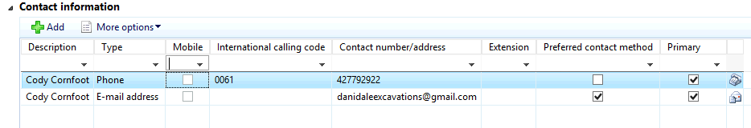

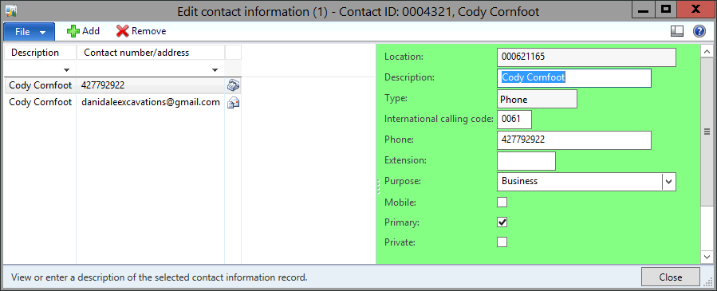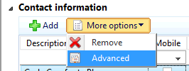

### Employment Information

|  |  |  |
| --- | --- | --- |
| **Field** | **Mandatory** | **Data Standard** |
| Job Title | N |  |
| Function | N | Select the department you are in e.g. if you are in Power Systems, select Power Systems. |
| Sensitivity | N | Default: Normal |

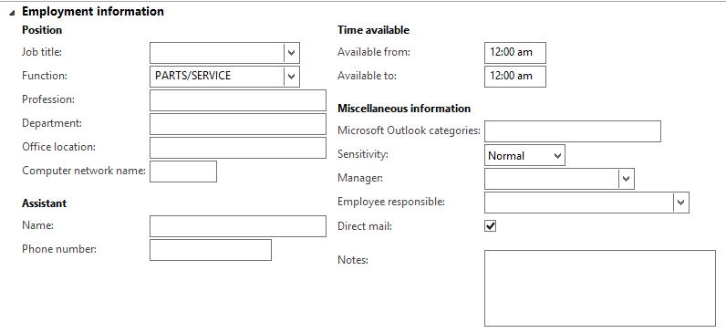

### Miscellaneous details

|  |  |  |
| --- | --- | --- |
| **Field** | **Mandatory** | **Data Standard** |
| Do Not Mail - Customer Request | N |  |
| Do Not Mail - Legal | N |  |
| Do Not Call | N | To be selected if requested by Customer |
| Do Not Email | N | To be selected if requested by Customer |
| Duplicate Contact | N |  |

